# Chandigarh College of Engineering & Technology (Degree Wing)

## Department of Computer Science & Engineering

REPORT Problem-6

Abdul Rahim (CO20301)

# Files included:

queue.c, report

# Data structure used:

## queue implementation of doubly linked list

**Outputs:** Following are the screenshots representing the outputs of different sets of data used in each method. The program was executed on VScode

**Insert_in_queue() method:**

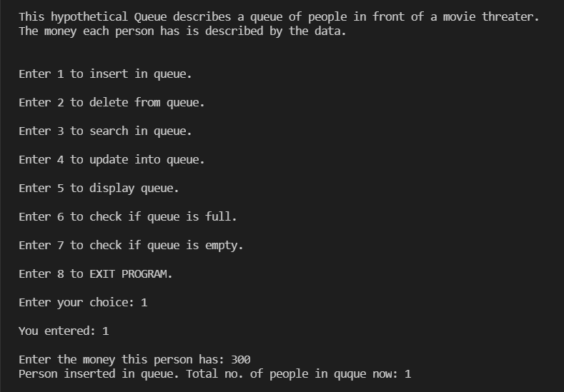

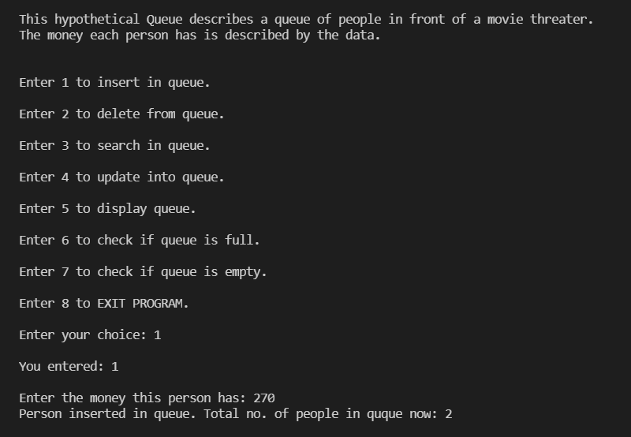

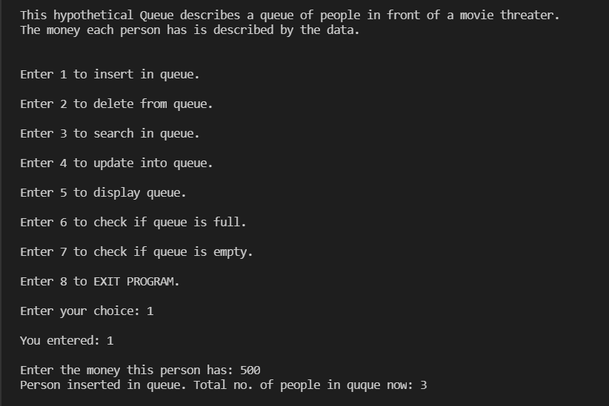

**Display:**

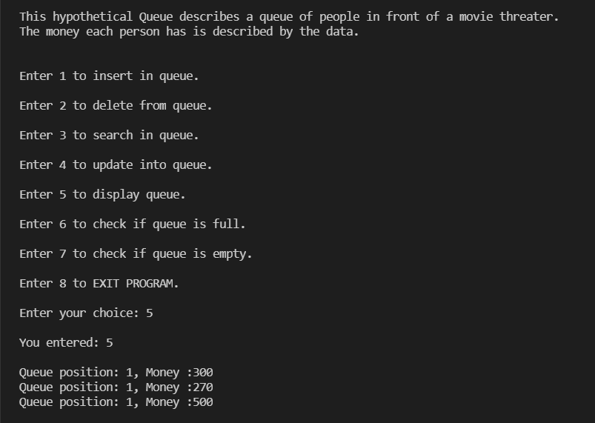

**Stack created:**

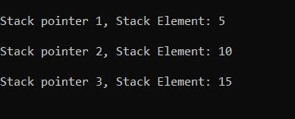

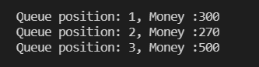Zoomed in view:

**Delete_from_queue() method:**

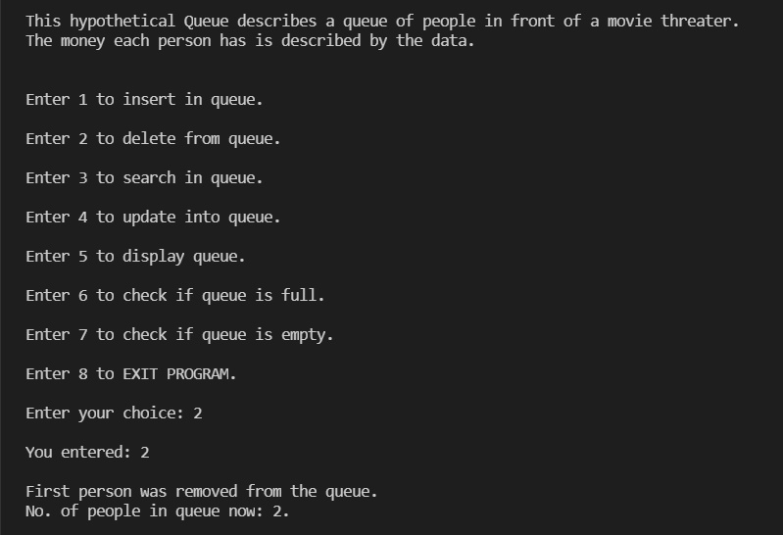

Displaying stack give**:**

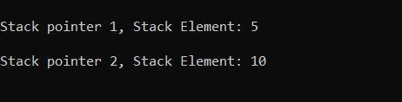

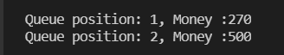

**Update:**

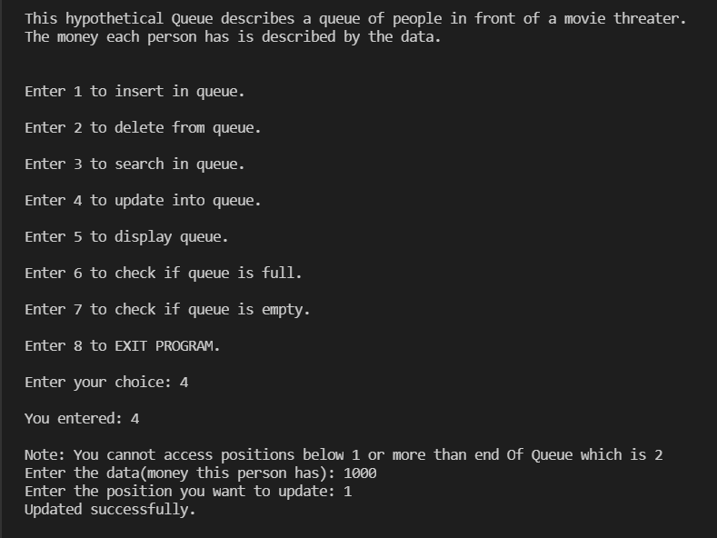

**Displaying updated stack:**

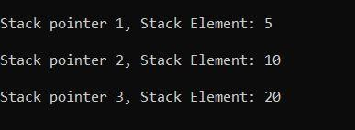

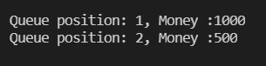

**Is full method():**

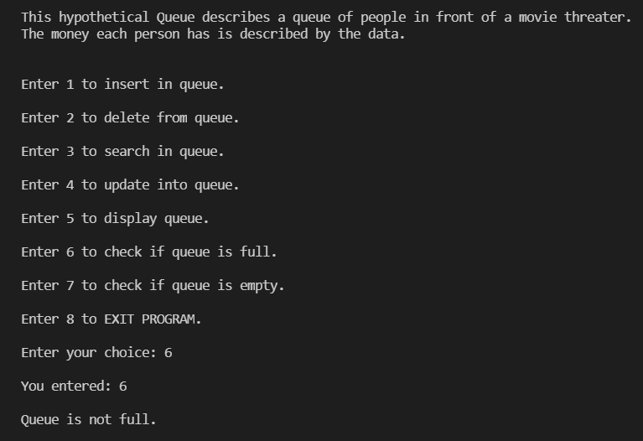

**Is empty method();**

**After two delete queue was empty:**

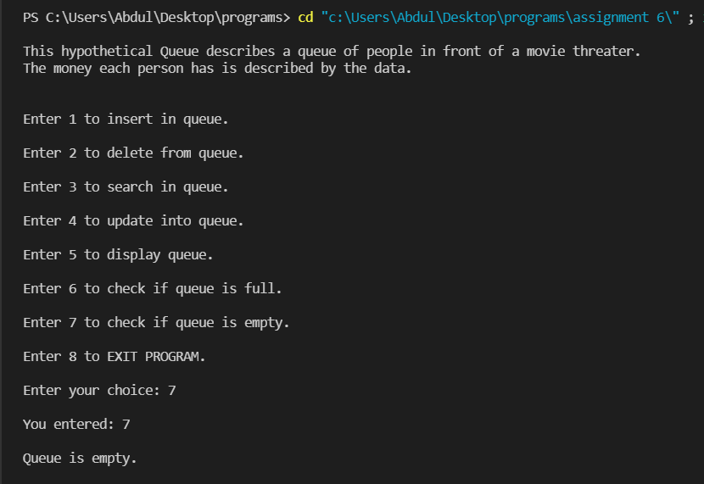

**Conclusion:**

Through the implementation of this program, we learned to perform various operation on the Queue data structure using doubly linked list. We learned how to link each method to each other and then finally to the main / control block of the program execution by working and designing Block diagrams and algorithms for each and every method. We learned how to implement Modular programming into our daily practice programs. We designed algorithms for every method before their implementation which made us think naturally rather than syntactically. For betterment, one could take a deep dive into the edge cases related to this or similar programs and debug those cases with a will to learn more and more.